**Instructions:**

**Part 1: Which Gestalt Principle could you use?**

When we implement data for explanatory purposes, we often leave our presentations with our intended audience.  The visualizations will include both text and visuals.  This is a challenge as, many times, this creates a lot of work for our audience and increases the cognitive load.  We must create visualizations that tie the text to the data.  This is accomplished using the Gestalt Principles we learned in class. Looking at the following graph, which Gestalt Principles can be implemented to tie the text to the graph?

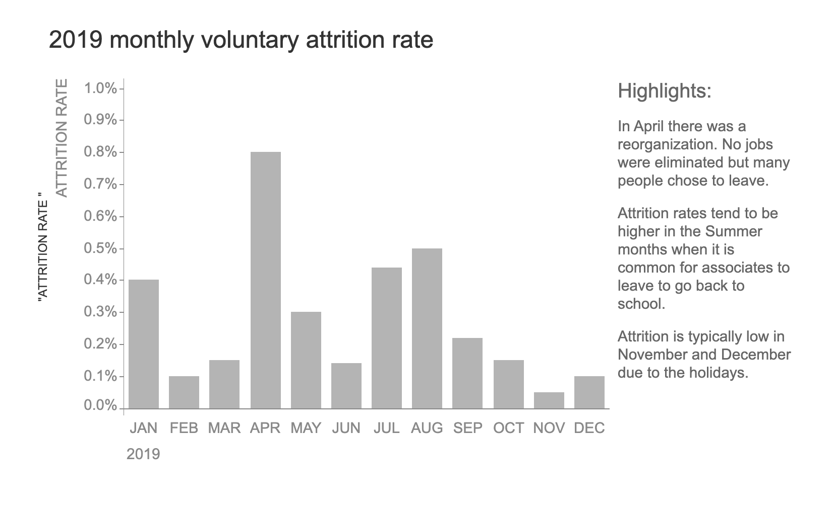

Match the following Gestalt Principles AND explain the differences between the four graphs with the graphs below.  Additionally, indicate which graph you believe would create the least cognitive load for the audience.

1. Proximity
2. Similarity
3. Enclosure plus similarity
4. Connection plus similarity

1. 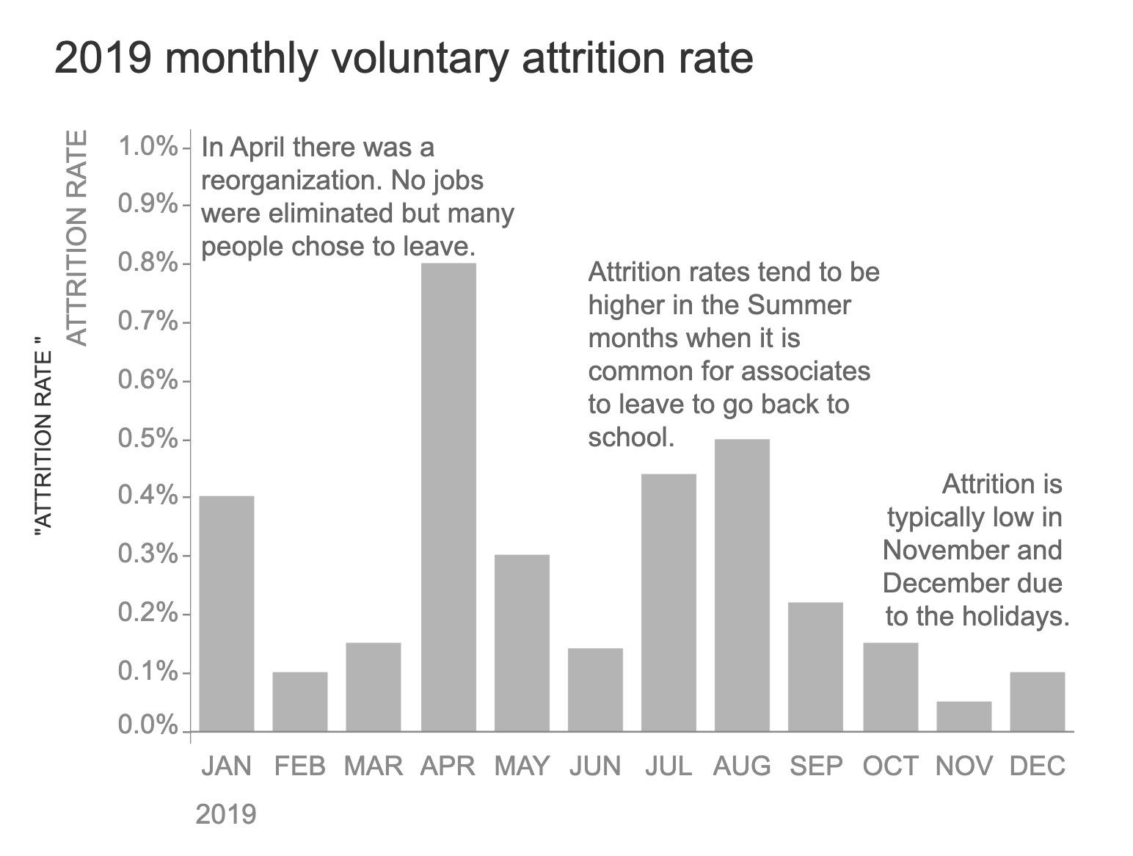
2. 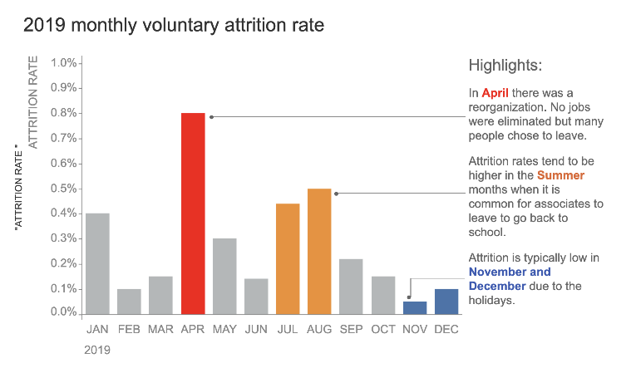
3. 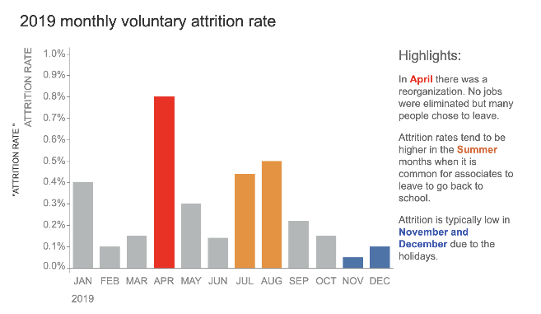
4. 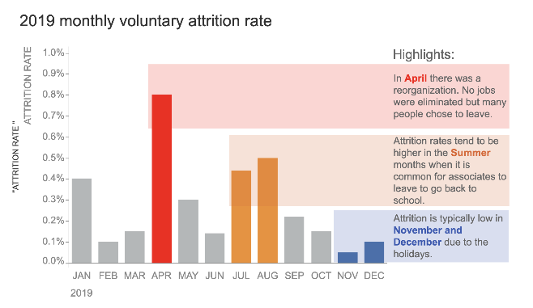

*This exercise is based on Exercise 3.2 in Let’s Practice.  Knaflic, C. N. (2019). Storytelling with data: Let's practice! (1st ed.). Wiley.*

**Part 2:  Color Selection**

Write a paragraph that describes at least 5 different colors explaining how the colors can affect our visualizations.

Discuss:

* Emotions
* Cultures
* Are they warm or cool colors?

**PART 3: Properties of Data**

Classify each variable (or attributes/columns) of the **Fall_2023_Track and Field** in Canvas (under the Dataset module) based on the following types of data discussed in the lectures:

N: Nominal

O: Ordinal

Q (Interval): Quantitative (Interval)

Q (Ratio): Quantitative (Ratio)

Creating a table is the best way to illustrate this part of the assignment. One variable can be classified as more than one type of data. Just be sure to justify your answer if you are in doubt.

**Submission:**

Remember, this is a **graduate-level course,** and **graduate-level writing** is expected.  This means you must provide proper citations when appropriate.  I do not require a specific citation style, but I want consistency in your references and in-text citations. **THIS IS NON-NEGOTIABLE!**

Please submit a Word doc in Canvas by the submission date in the syllabus, no later than 11:59 pm to avoid any deductions for late work.

By submitting this assignment, you agree to the UNT honor code.**“I commit myself to honor, integrity, and responsibility as a student representing the University of North Texas community. I understand and pledge to uphold academic integrity as set forth by UNT Student Academic Integrity Policy, 06.003. I affirm that the work I submit will always be my own, and the support I provide and receive will always be honorable.”**

See the rubric for additional information on the grading of this assignment.

View Rubric

|  |
| --- |
| Design and Best Practices Assignment |
|  |